**Sarcasm Analysis in Emoji Prediction**

**Word Wizards: Danial Syed, Alex Iliarski, Sai Tarun Inaganti, Jiayi Huang**

(syed0053, iliar004, inaga015, huan1920) @umn.edu

CSCI5541, University of Minnesota

**1 Motivation**

Sarcasm is a prevalent phenomenon in human communication, where the intended meaning is opposite to the literal interpretation of the message. In-person conversations yield sarcasm by including tone and body language. However, in digital communication, sarcasm is often expressed using textual cues such as punctuation, capitalization, and emojis.

Emojis have become a popular way of conveying emotions and attitudes in digital communication. They are used extensively in social media platforms and messaging apps. Emojis are used to express a range of emotions such as happiness, sadness, anger, and sarcasm.

The use of emojis in digital communication has given rise to a new research area called Emoji Prediction. The goal of Emoji Prediction is to predict the most appropriate emoji that should be used to express the intended emotion or attitude in a given text. However, most existing Emoji Prediction models do not take into account the presence of sarcasm in the text, which can significantly affect the choice and interpretation of emojis.

**2 Problem Definition**

The problem arises when the meaning of an emoji is not clear, and it is difficult to understand the intent of the message. It can be difficult to identify and interpret sarcasm in written text, which can lead to misunderstandings and miscommunications.

For example, 🤡 can have a variety of interpretations, such as calling someone foolish, funny, or dumb, depending on its textual context. This issue is prevalent when emojis are used in an unorthodox manner. For example, if I were to tweet, “Proud to announce I’ll be working for a startup this summer!” and someone were to reply with 🤡, it can be interpreted as me being a fool for choosing this path. Realizing accurate sarcastic examples and models are vital to the future of natural language processing as it incorporates those physical gestures (tone, body language) that we are unable to identify in text.

Additionally, the same emoji in the same context could have different meanings depending on who is saying it. For example, if a tweet announces “The Vikings have lost their playoff game,” then a fan of the team may respond with shock 😲. On the other hand, a sports commentator who often expressed their doubt in the team’s ability may respond sarcastically with a shock face 😲 to show their lack of surprise.

All in all, there are many contextual and personal factors that are in play when it comes to sarcasm. Thus, a broad sarcasm classifier can be useful to classify situations that could possibly or most probably be sarcastic, so a model can understand there isn’t as much certainty in the text’s information.

Our goal is to develop a system for predicting the accuracy of an emoji's reaction to its individual, respective text. This system will analyze a given text and produce a possible list of appropriate emojis and identify those that are genuine responses and those that are sarcastic responses.

**3 Literature Survey**

With the rise of digital interactions, a parallel boom of emoji research and equivalent NLP implementations has also occurred. Numerous studies have explored the use of emojis in different contexts. For example, Bjarke et al. (2017) proposed a model for sentiment analysis using emojis and achieved high accuracy rates.

Regarding emoji analysis several approaches have been proposed in the literature. A common approach is to use machine learning algorithms to identify the context and overall sentiment of the individual. For instance, Shirley et al. (2019) proposed a model for detecting sarcasm in Twitter messages using a combination of lexical, syntactic, and semantic features.

However, limited research has focused specifically on predicting the meaning of emojis in sarcastic contexts. This is a challenging task since the meaning of an emoji can vary depending on the context in which it is used.

**4 Proposed Idea**

Our proposed research has several potential applications, but we are focused on improving the accuracy of Emoji Prediction models by enhancing the understanding of sarcasm in digital communication. We plan on extending previous research of irony detection Shirley et al. (2019) by using the same dataset of recently published tweets Van Hee et al. (2018) and the correlating big 20 of emoji’s Shirley et al. (2019).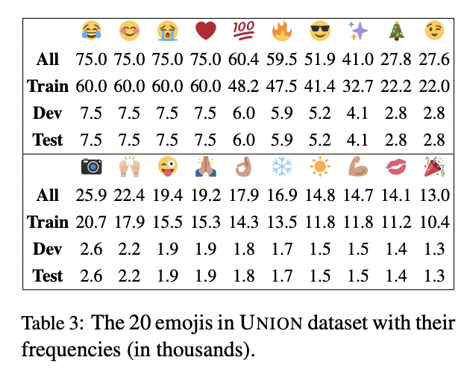

We will differentiate ourselves by labeling emojis on being sarcastic or non-sarcastic, but also identifying the positivity or negativity of the sarcasm itself. This will help promote if the sarcasm is appropriate(non-toxic) or inappropriate(toxic) which will help identify which sarcastic reactions are beneficial and which could be hurtful.

**5 Broader Impact**

This system for predicting the meaning of emojis in sarcastic contexts will have a significant impact on improving online communication. By accurately interpreting the use of emojis in sarcastic contexts, misunderstandings and miscommunications can be minimized. More specifically, sarcasm can often lead to toxic behaviors. Early forewarnings of sarcasm can help deflect future hindrances on individuals and improve mental and social health.

Furthermore, this system can benefit several realms of our digital world such as social media, chat support, and marketing. For example, companies can use the system to analyze customer feedback, allowing them to efficiently observe the results and impact of their service/product. It can also be used to analyze social media posts and predict public sentiment, which can influencers determine the impact of their testimonies.

The development of this system can also contribute to the advancement of natural language processing and machine learning. The proposed system will be groundbreaking with regards to image recognition, rather than just plain text. This can lead to new insights and advancements in the research community and contribute to the evolution of this growing field.

**6 References**

Bjarke Felbo, Alan Mislove, Anders Søgaard, Iyad Rahwan, and Sune Lehmann. 2017. Using millions of emoji occurrences to learn any-domain representations for detecting sentiment, emotion and sarcasm. In Proceedings of the 2017 Conference on Empirical Methods in Natural Language Processing, pages 1615–1625, Copenhagen, Denmark. Association for Computational Linguistics.

Weicheng Ma, Ruibo Liu, Lili Wang, and Soroush Vosoughi. 2020. Multi-resolution Annotations for Emoji Prediction. In Proceedings of the 2020 Conference on Empirical Methods in Natural Language Processing (EMNLP), pages 6684–6694, Online. Association for Computational Linguistics.

Shirley Anugrah Hayati, Aditi Chaudhary, Naoki Otani, and Alan W Black. 2019. What A Sunny Day ☔: Toward Emoji-Sensitive Irony Detection. In Proceedings of the 5th Workshop on Noisy User-generated Text (W-NUT 2019), pages 212–216, Hong Kong, China. Association for Computational Linguistics.

Cynthia Van Hee, Els Lefever, and Véronique Hoste.

2018. Exploring the fine-grained analysis and automatic detection of irony on twitter. Language Resources and Evaluation, 52(3):707–731.